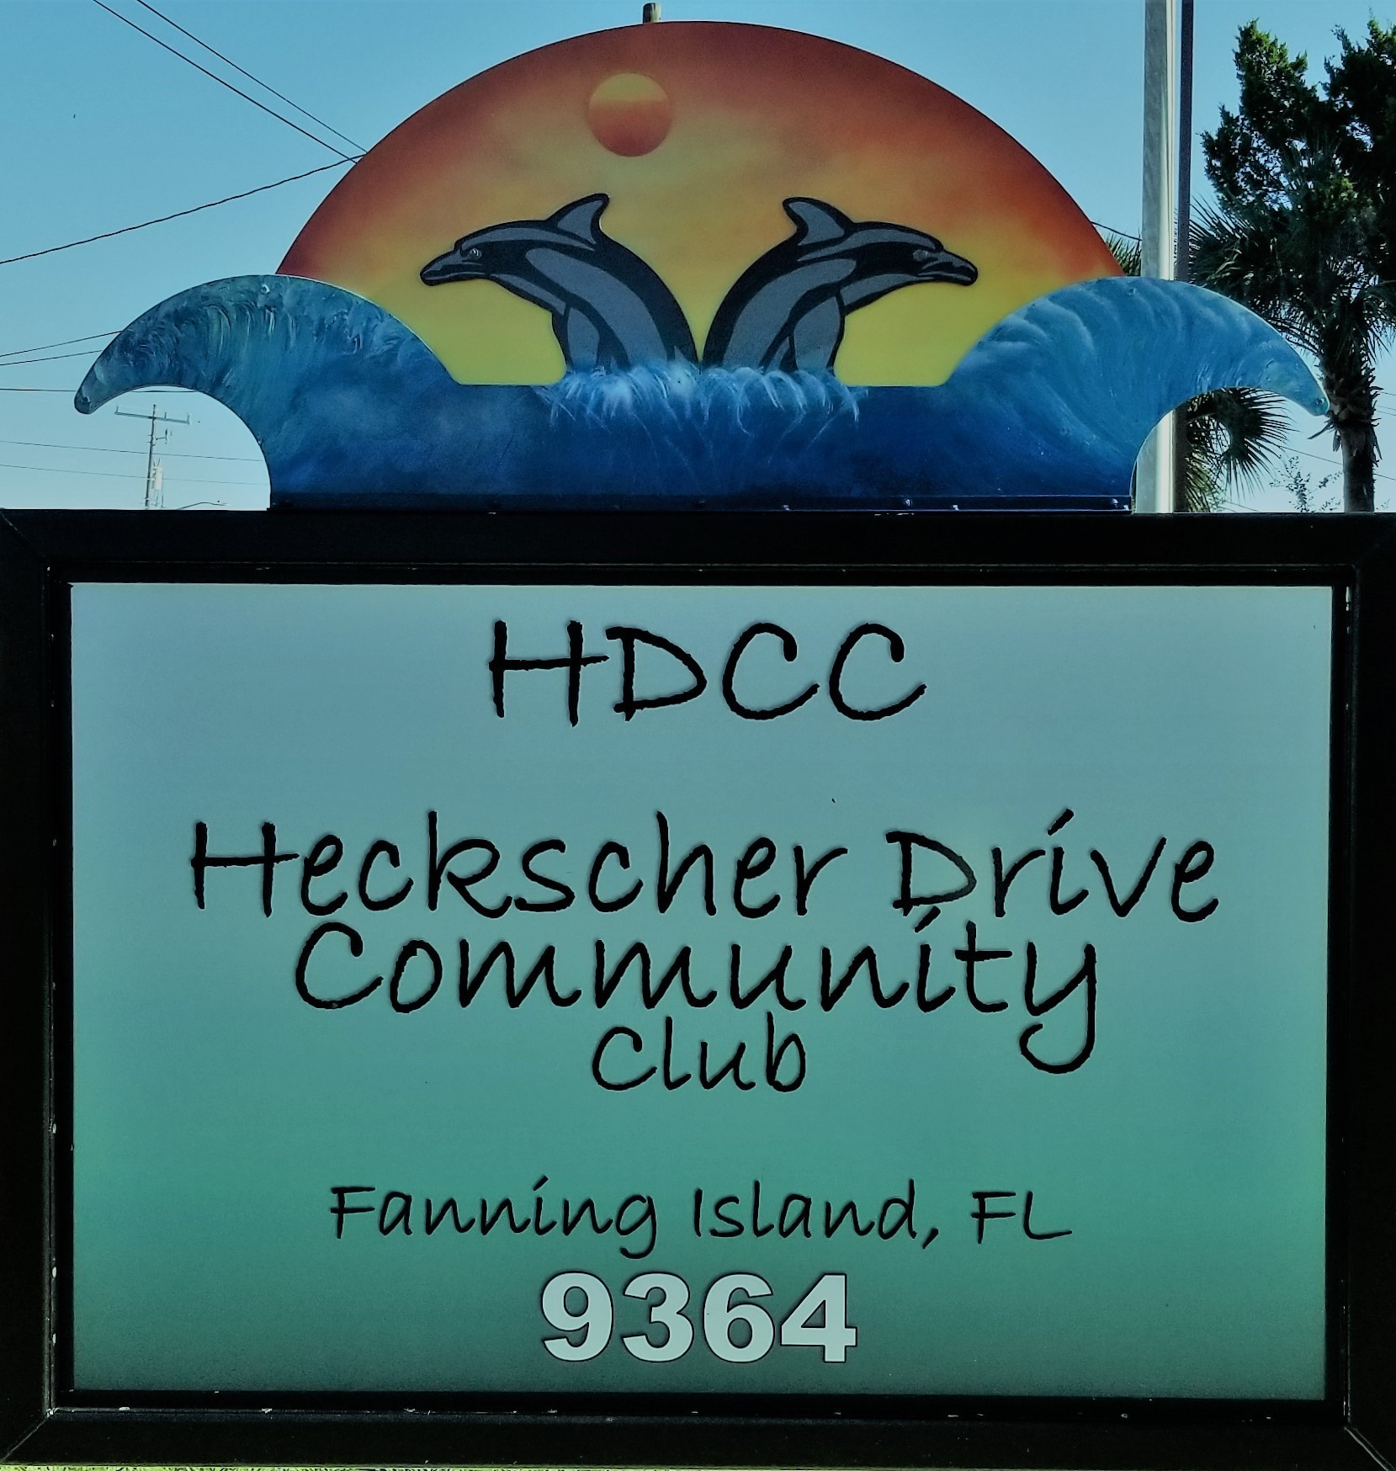

Dear Neighbor,

Welcome to our great neighborhood. We hope to soon welcome you as new members of Heckscher Drive Community Club. You may or may not already be aware of our neighborhood organization. Heckscher Drive Community Club is a 501(c)4 Civic League. Our efforts center around being a voice for the community and its wonderful environment as well as offering events and meetings aimed at getting to know neighbors and socializing with them.

We refer to our community as one street wide, 10 miles long, and having 6 side-neighborhoods. One aspect making HDCC strong and thriving, for over 70 years, is its strong organization governed with By-Laws. These By-Laws are our rules of the road, for conducting any business of our voluntary non-profit neighborhood association. What our by-laws are NOT: they are not used for neighborhood covenants nor do they hold sway over property owners' rights. We invite you to join our North Florida Keys and the Heckscher Drive Community Club. Our By-Laws and Standing Rules can be sent electronically upon join if you request them.

After joining, our Treasurer will add you to the HDCC roster of members. We do not share information outside of HDCC. Our President will include you in the monthly email list, so you can enjoy receiving timely articles of concern for our neighborhood as well as the monthly newsletter. All newsletters are posted at
www.hdccjax.org.

Finally, we look forward to meeting you and having an enjoyable time getting together with your neighbors. Please direct any questions about HDCC to any of our Club officers. To indicate your desire to join please fill out the attached form.

Best Regards,

Mark Sakaguchi
President
HDCCPres50@gmail.com

HDCC 2023 Membership - $70 p/p per calendar year
Please fill out below and pay $70/per person dues; drop dues in the HDCC mailbox, or bring it to next meeting or MAIL to: 9364 Heckscher Dr., Jax, FL 32226.
Make checks payable to: HDCC.
Renewing members: update changed information
New members: please provide info as per below
Full Name:
Spouses Name:
Other members of household:
Home Address:
Birthday(s) and/or Anniversary (not mandatory):
Cell Phone / Hm Phone:
Email(s):
Comments or Suggestions - What events or directions would you like HDCC to pursue?

I will observe and support the legal rules, regulations and commitments of the Heckscher Drive Community Club. (please sign):

Members Signature of Acceptance

HDCC 2023 Business Membership
Please fill out below and pay $350 for business dues; drop dues in the HDCC mailbox, or bring it to next meeting or MAIL to: 9364 Heckscher Dr., Jax, FL 32226.
Make checks payable to: HDCC
Renewing business members: update changed information
NEW Business: please provide info as per below
Business Name:
Business Address:
Business Contact Phone:
Business Contact Email(s):
Comments or Suggestions - What events or directions would you like HDCC to pursue?

This business will observe and support the legal rules, regulations and commitments of the Heckscher Drive Community Club. (please sign):

Business Member Signature of Acceptance

